Food Studies 11/12 Name: ______________________
BCCS Block: __________
Chicken Pad Thai (1 recipe per unit)
Ingredients
250g flat rice noodles
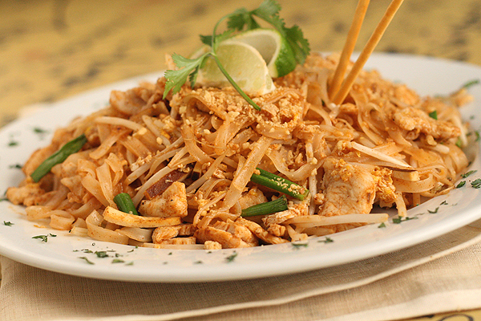
60g chicken breast OR shrimp
50 mL tofu
1 carrot
30 mL bean sprouts
30 mL lime juice
30 mL soy sauce
20 mL fresh grated ginger
2 mL chilli sauce
15 mL oil
1 garlic clove, minced
2 green onions
15 mL cilantro
15 mL chopped toasted peanuts (optional)

Method:
- Soak noodles in hot water for 20 minutes or until soft. Drain and reserve.
- Cut chicken into thin strips and place win a bowl.
- Trim the bean sprouts if needed. Julienne the carrots. Put into a small bowl.
- In a separate bowl, stir together lime juice, soy sauce, ginger, and chilli sauce.
- Drain the tofu and cut into ½ inch cubes.
- Heat 15 mL oil in frying pan. Add the tofu and sauté until golden, stirring often. Set aside
- In a wok, heat over high heat. Stir fry the garlic for 10 seconds and then add the shrimp or chicken and carrots.
- Stir fry until chicken is no longer pink. Add the noodles and half of the sauce. Stir. Cook until the noodles are heated through.
- Stir in bean sprouts, green onion, tofu, and remaining sauce. Cook for one minute.
- Put the food on a dish and garnish with fresh cilantro and peanuts.

Adaptations
** You are using more than 60 grams of chicken so we are omitting the tofu
**At home you can garnish the peanuts but at school we will omit this step

